

|  |  |
| --- | --- |
| **Intake: APD1F2409CS(CYB)** | **Module Code: CT042-3-1-IDB** |

|  |
| --- |
| **Hand Out Date: Tuesday, 22 October 2024 Week 3** |
| **Submission Date:** **Tuesday, 14 January 2025 Week 12** |

**TITLE:**

***Community E-Library Management System (CELMS) Part 2***

**Module Lecturer: Mrs. Lai Chew Ping**

**Group No. 2**

|  |  |  |
| --- | --- | --- |
| **No.** | **Name** | **TP** |
| **1** | AHMED MIRAHUSAIN ALVI | TP084807 |
| **2** | MAHRUS SHAMSUL AHSAN | TP085562 |
| **3** | SULTAN ABDULLA OMAR TAKRORI | TP085327 |
| **4** | ABDALLAH MOHAMED MAHMOUD MOHAMED MAHMOUD | TP085097 |
| **5** | MOHAMMED YOUSEF MOHAMMED MOHAMMED | TP085042 |

**TABLE OF CONTENTS**

**CHAPTER 1: DATABASE SCHEMA**

**1.1 ENTITY RELATIONSHIP DIAGRAM…………………………………………….…..1**

**1.2DATABASE DIAGRAM FROM DBMS…………………......….………………………2**

**CHAPTER 2: SQL DATA DEFINITION LANGUAGE (DDL)**

**2.1 DATABASE CREATION ANDIMPLEMENTATION………………………………...3**

**2.2 MEMBERS TABLE……………………………………………………...........................4**

**2.3 FEEDBACK TABLE……………………………………………………………………..5**

**2.4 ROOMS TABLE………………………………………………………………………….6**

**2.5 RESERVATION TABLE………………………………………………...........................7**

**2.6 LOGS TABLE………………………………………………………………………….....8**

**2.7 AUTHORS TABLE…………………………………………………………………........9**

**2.8 PUBLISHERS TABLE………………………………………........................................10**

**2.9 CATEGORIES TABLE………………………………………………………………...11**

**2.10 POPULAR GENRES TABLE…………………………………...................................12**

**2.11 ITEMS TABLE………………………………………………………………………...13**

**2.12 BORROWED ITEMS TABLE……………………………………………………….14**

**CHAPTER 3: SQL DATA MANUPULATION LANGUAGE (DML)**

**3.1 DML QUERY 1.…………………………………………………………………………15**

**3.2 DML QUERY 2.…………………………………………………………………………16**

**3.3 DML QUERY 3.…………………………………………………………………………17**

**3.4 DML QUERY 4.…………………………………………………………………………18**

**3.5 DML QUERY 5.…………………………………………………………………………19**

**3.6 DML QUERY 6.…………………………………………………………………………20**

**3.7 DML QUERY 7.…………………………………………………………………………21**

**3.8 DML QUERY 8.…………………………………………………………………………22**

**3.9 DML QUERY 9.…………………………………………………………………………23**

**3.10 DML QUERY 10...……………………………………………………………..………24**

**3.11 DML QUERY 11...……………………………………………………….…………….25**

**3.12 DML QUERY 12...……………………………………………………………………26**

**3.13 DML QUERY 13...……………………………………………………………………27**

**3.14 DML QUERY 14...……………………………………………………………………28**

**3.15 DML QUERY 15...…………………………………………………..…………….….29**

**APPENDIX: WORKLOAD MATRIX………………………………………………...……...….30**

**CHAPTER 1: DATABASE SCHEMA**

***1.1*** *ENTITY RELATIONSHIP DIAGRAM (ERD)*

***1.2*** *DATABASE DIAGRAM FROM DBMS*

**CHAPTER 2: SQL – DATA DEFINITION LANGUAGE**

***2.1*** *DATABASE CREATION AND IMPLEMENTATION*

***2.2*** *Members Table*

This table contains data about library members. Each member has a unique identifier (MemberID), along with their name, contact details, neighborhood, join date, active status, gender, and age.

Creating Table:

Inserting Records:

Display Data (Output):

***2.3*** *Feedback Table*

This table contains data about member feedback. Each feedback entry has a unique identifier (FeedbackID), the member who submitted it, content, and submission date.

Creating Table:

Inserting Records:

Display Data (Output):

***2.4*** *Rooms Table*

This table contains data about meeting rooms. Each room has a unique identifier (RoomID), number, capacity, and availability status.

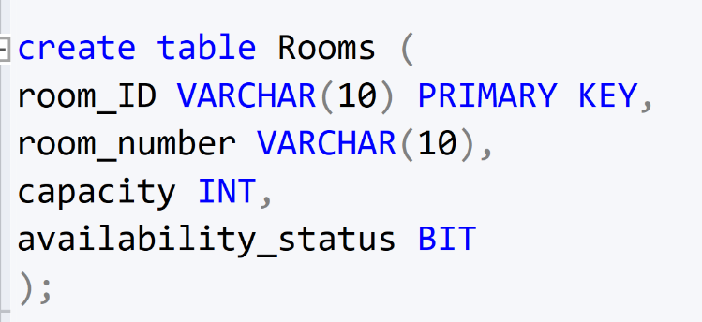Creating Table:

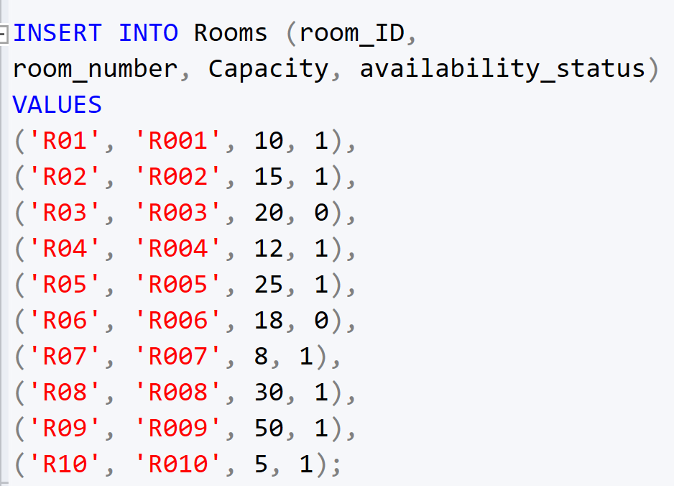Inserting Records:

Display Data (Output):

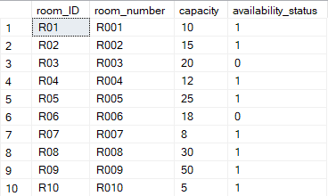

***2.5*** *Reservations Table*

This table contains data about meeting room reservations. Each reservation has a unique identifier (ReservationID), the member who reserved, the room, date, time, and activity description.

Creating Table:

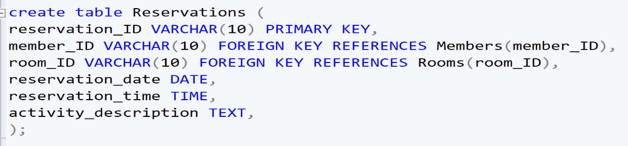

Inserting Records:

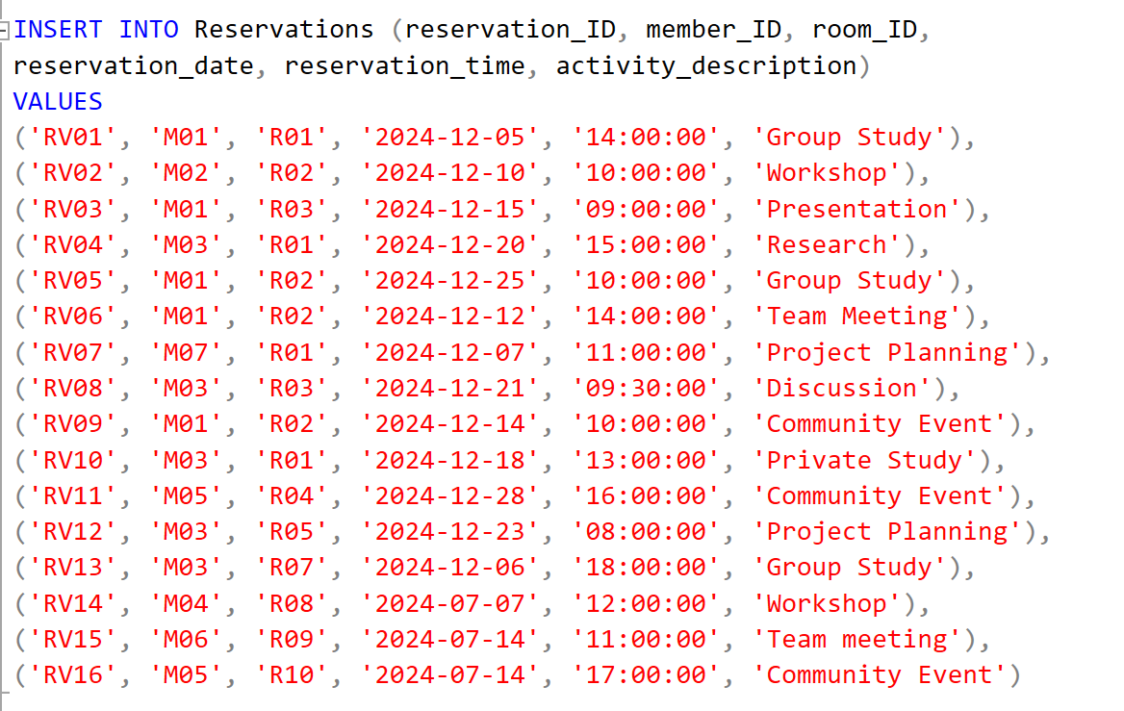

Display Data (Output):

***2.6*** *Logs Table*

This table records system events and user activities. Every single log entry has a unique identification number (LogID), which describes the log action taken, the time the action took place and the person who did the action.

Creating Table:

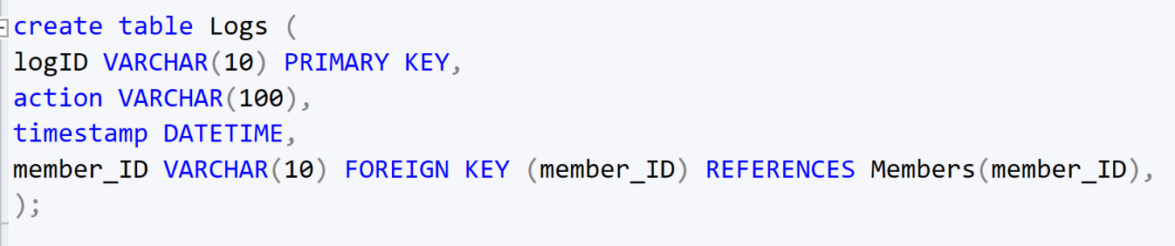

Inserting Records:

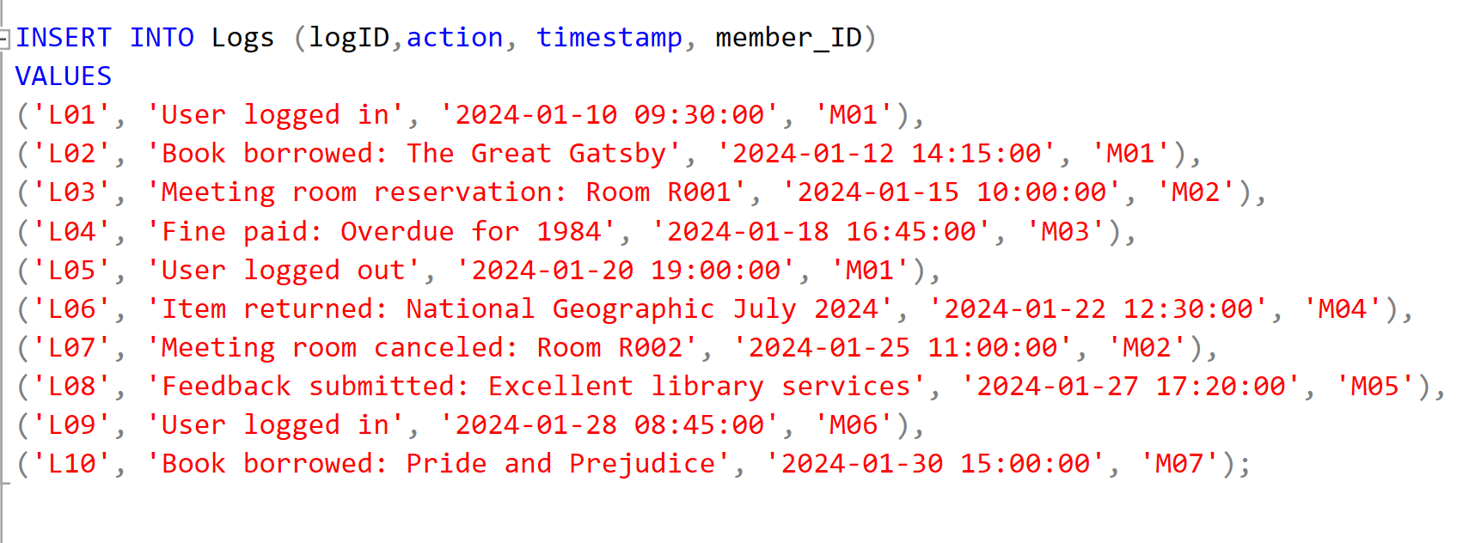

Display Data (Output):

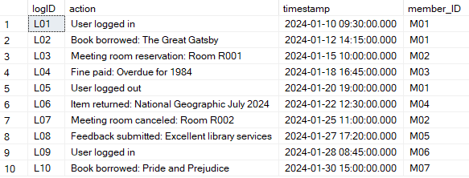

***2.7*** *Authors Table*

This is a table that collects all information related to the authors such as an id (AuthorID), their name and brief information about that author.

Creating Table:

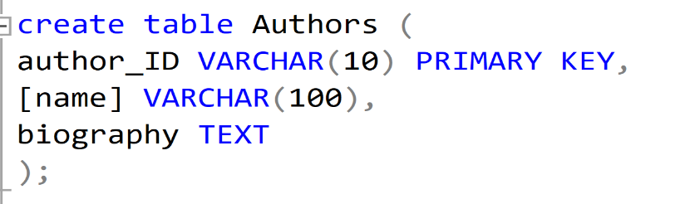

Inserting Records:

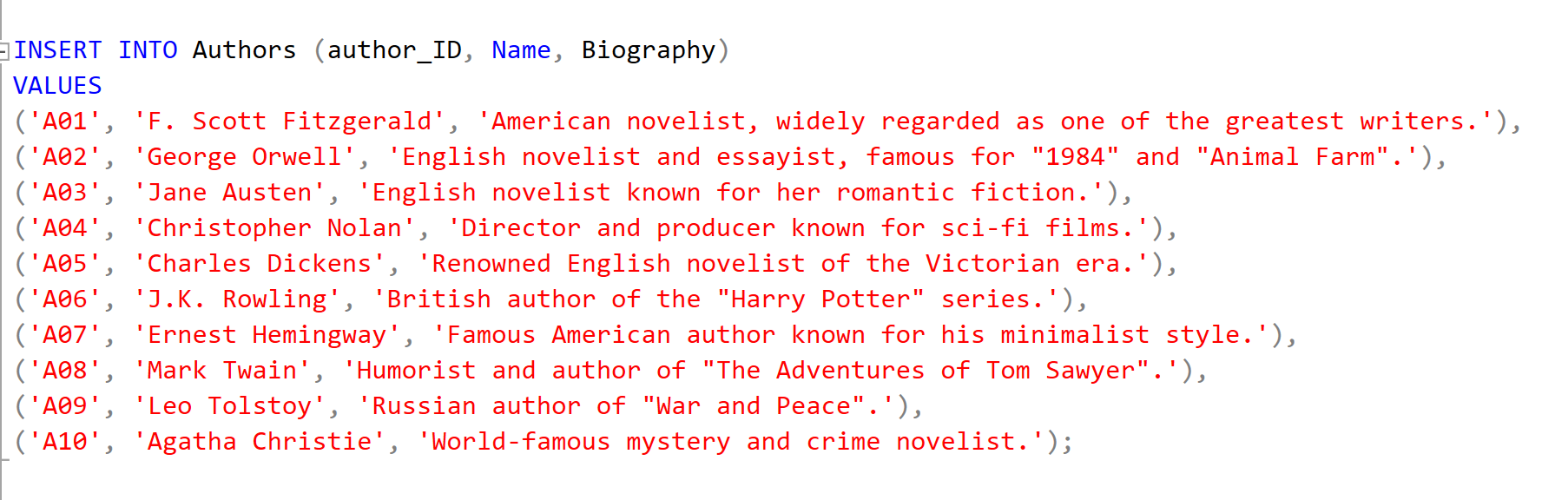

Display Data (Output):

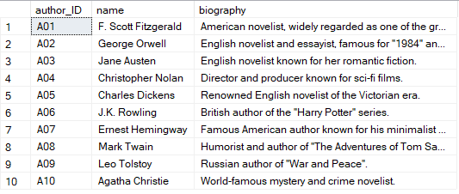

***2.8*** *Publishers Table*

This table contains data about publishers. Each publisher has a unique identifier (PublisherID), name, address, and contact details.

Creating Table:

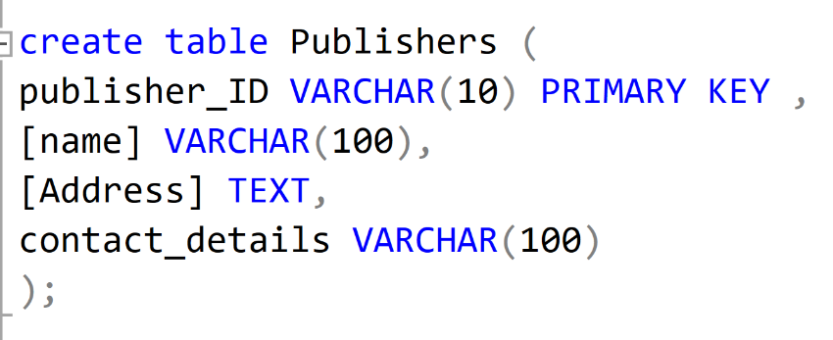

Inserting Records:

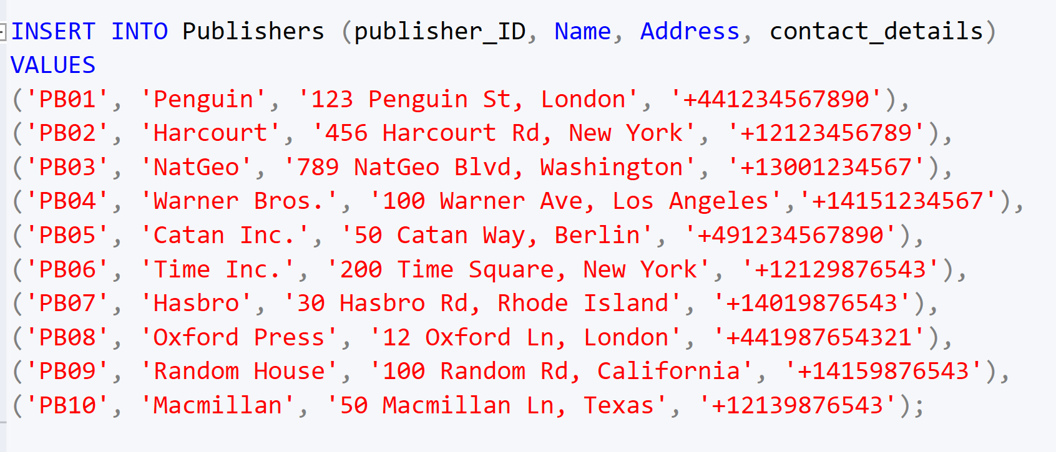

Display Data (Output):

***2.9*** *Categories Table*

This is the table which classifies items into categories. Each category has its own identification number (CategoryID), name with borrowing restrictions.

Creating Table:

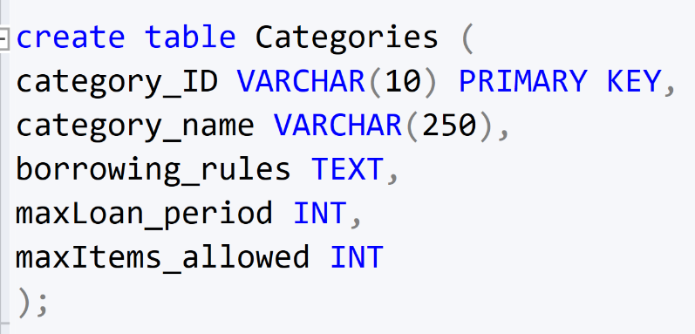

Inserting Records:

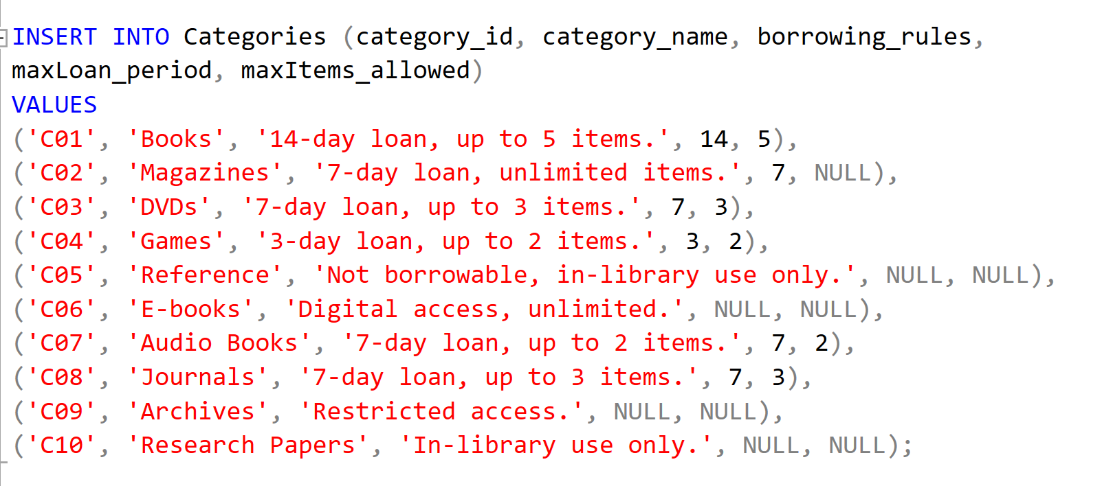

Display Data (Output):

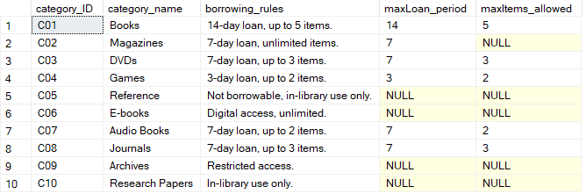

***2.10*** *Popular Genres Table*

This table contains information about the least genres borrowed in the library. Every such entry contains an identification number (GenreID), the title of the genre, and the number of times it was borrowed.

Creating Table:

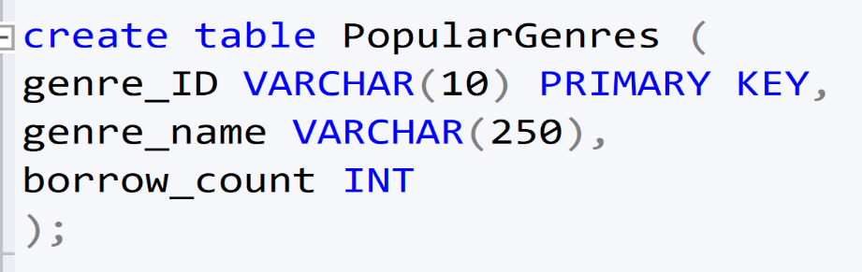

Inserting Records:

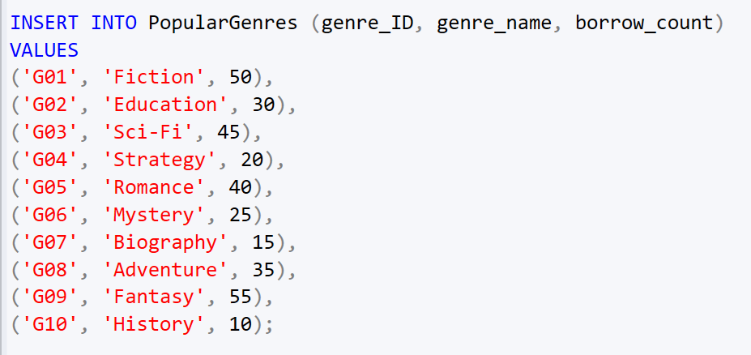

Display Data (Output):

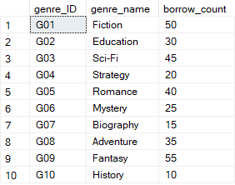

***2.11*** *Items Table*

This is a table that holds the information regarding the inventory of the library. This information consists of books, magazines, DVDs, board games, etc. Each item has a unique identifier (ItemID) along with its title, author, genre, a short scope, and rules for borrowing of the item.

Creating Table:

Inserting Records:

Display Data (Output):

***2.12*** *Borrowed Items Table*

This table contains data about borrowed items. Each record tracks the borrowing details, such as the member, item, due date, return date, overdue days, and fines.

Creating Table:

Inserting Records:

Display Data (Output):

**CHAPTER 3: SQL – DATA MANIPULATION LANGUAGE**

***3.1*** *DML Query 1:*

***List all the items name, descriptions, category name and category description that are currently not on loan and available for loan. Order the result by category.***

Display Data (Output):

***3.2*** *DML Query 2:*

***Show members who had paid overdue more than 2 times for rental items. The results must consist of their first name, last name, contact number, number of overdue, and total due amount. Show the results according to neighborhood.***

Display Data (Output):

***3.3*** *DML Query 3:*

***Display the active members and list of books they have borrowed in the years 2022 and 2023. The result must consist of members’ first name, last name, book name, and the borrow date. Sort the result by borrowed year in ascending order.***

Display Data (Output):

***3.4*** *DML Query 4:*

***Show the members who have borrowed items at least 8 times this year. Display their name, item description and the numbers of items they have borrowed.***

Display Data (Output):

***3.5*** *DML Query 5:*

***Display the members’ name and contact number as well as name and description of the items borrowed the most. Order the result by category type.***

Display Data (Output):

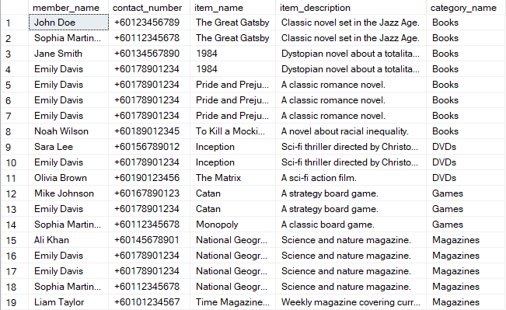

***3.6*** *DML Query 6:*

***Calculate the total fine for a member based on the items they have borrowed.***

Display Data (Output):

***3.7*** *DML Query 7:*

***Show members who have reserved a meeting room more than three times in the last month.***

Display Data (Output):

***3.8*** *DML Query 8:*

***Display the most popular genre of items (books, DVDs, etc.) based on the number of times items in that genre have been borrowed.***

Display Data (Output):



***3.9*** *DML Query 9:*

***Write query to find number of meeting rooms that are available on 12 October 2024. Order by room number.***

Display Data (Output):

***3.10*** *DML Query 10:*

***List out all rooms that have been reserved on month of July 2024. Show them according to the activity***

Display Data (Output):

***3.11*** *DML Query 11:*

*Show the number of books written by each author, sort the result according to book count (author with most books sorted on top).*

Display Data (Output):

***3.12*** *DML Query 12:*

***Display members have neither borrowed items nor reserved rooms in year 2023.***

Display Data (Output):

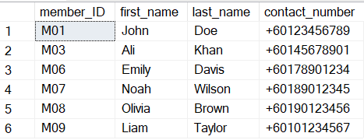

***3.13*** *DML Query 13:*

***Among the books borrowed in the year 2024, show the list of books that cost the most.***

Display Data (Output):



***3.14*** *DML Query 14:*

***Show the publisher whose books are least-in-quantity by genre.***

Display Data (Output):

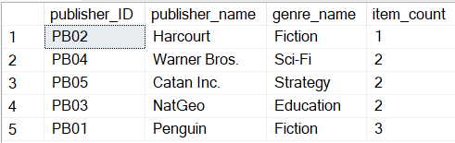

***3.15*** *DML Query 15:*

***Show the number of male member(s) who have reserved the rooms in the library whose age are more than the average age of all members.***

**Display Data (Output):

**APPENDIX: WORKLOAD MATRIX**

|  |  |  |  |  |  |  |  |
| --- | --- | --- | --- | --- | --- | --- | --- |
| **Part** | **Component** | **Student 1 Name:** **AHMED MIRAHUSAIN ALVI TP084807** | **Student2 Name:** **MOHAMMED YOUSEF MOHAMMED MOHAMMED**  **TP085042** | **Student 3 Name:** **ABDALLAH MOHAMED MAHMOUD MOHAMED MAHMOUD**  **TP085097** | **Student 4 Name:**  **SULTAN ABDULLA OMAR TAKRORI**  **TP085327** | **Student 5 Name:**  **MAHRUS SHAMSUL AHSAN**  **TP085562** | **Total** |
| **1** | 1. Database and Database Management System | **20%** | **20%** | **20%** | **20%** | **20%** | **100%** |
| **1** | 1. Business Rules & Normalization | **20%** | **20%** | **20%** | **20%** | **20%** | **100%** |
| **1** | 1. Entity Relationship Diagram | **20%** | **20%** | **20%** | **20%** | **20%** | **100%** |

|  |  |  |  |  |  |  |  |
| --- | --- | --- | --- | --- | --- | --- | --- |
| **Part** | **Component** | **Student 1**  **Name:**  **AHMED MIRAHUSAIN ALVI TP084807** | **Student 2**  **Name:**  **MOHAMMED YOUSEF MOHAMMED MOHAMMED**  **TP085042** | **Student 3**  **Name:**  **ABDALLAH MOHAMED MAHMOUD MOHAMED MAHMOUD**  **TP085097** | **Student 4**  **Name:**  **SULTAN ABDULLA OMAR TAKRORI**  **TP085327** | **Student 5**  **Name:**  **MAHRUS SHAMSUL AHSAN**  **TP085562** | **Total** |
| **2** | 1. Database Schema | **20%** | **20%** | **20%** | **20%** | **20%** | **100%** |
| **2** | 1. DDL | **20%** | **20%** | **20%** | **20%** | **20%** | **100%** |
| **2** | 1. DML | **20%** | **20%** | **20%** | **20%** | **20%** | **100%** |